HEALTHCARE ANALYTICS Data Cleaning Report[Grp_20]

Project Title:
Data-Driven Chronic Disease Management in Rural Africa
Focus:
Hypertension and associated chronic conditions
File: click here for the Ipynb document used for this cleaning process.

1. Introduction
This report documents the steps taken to clean and prepare the healthcare dataset for analysis. The dataset comprises 319,795 records and 18 columns(precleaning) related to patient health conditions, lifestyle factors, and demographics. The goal is to ensure the data is accurate, consistent, and ready for subsequent analysis—especially for building KPIs and predictive models to understand hypertension prevalence and its risk factors.

2. Data Quality Assessment
2.1 Missing Values
The following columns had missing values:
- Stroke: 5 missing
- MentalHealth: 1 missing
- Sex: 4 missing
- Diabetic: 14 missing
- PhysicalActivity: 11 missing
- SleepTime: 4 missing
- Asthma: 6 missing
- KidneyDisease: 6 missing
- SkinCancer: 9 missing
Handling:
We were provided a reference dataset (“Hyper-disease”), which we used to fill in the missing values in the original dataset.

2.2 Duplicate Records
- The dataset initially contained 18,078 duplicate values which were dropped to ensure data integrity.

2.3 Inconsistent Formatting and Column Names
- We ensured there were no accidental spaces in the column names by using:
healthcare_data.columns = healthcare_data.columns.str.strip() to remove white spaces if any.
- The target variable column was renamed from "Hypertension-heartdisease)" to "Hypertension" for clarity and to match the column name in our reference dataset.
- The "Sex" column was renamed "Gender" to standardize demographic labels.

2.4 Data Entry Errors and Inconsistencies
We verified data consistency across categorical columns by checking the unique entries across each column.
No inconsistencies or errors were found based on these checks.

2.5 Outlier Detection
Using the Interquartile Range (IQR) method on the `BMI` column:
- Number of outliers in BMI: 8,905
  - Outliers below 12.6(lower_bound): 24 records
  - Outliers above 43.08(upper_bound): 8,881 records

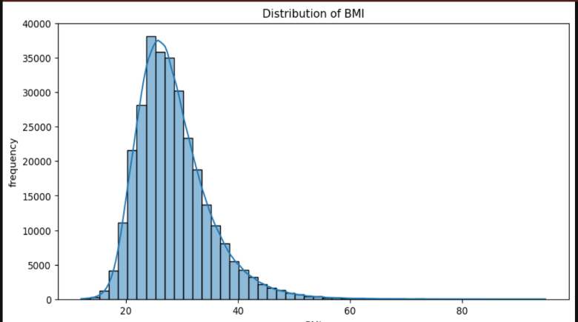
A histogram of the BMI distribution indicated a right-skewed distribution—most individuals have a BMI between 18 and 40, with a long tail extending toward high values (between 60 and 80). These high BMI values are important for understanding the impact of overweight on hypertension and thus were not removed.
- Strategy:
Instead of modifying or removing these outliers—since high BMI can provide insights into the relationship with hypertension—we applied a segmentation method.
- Segmentation Approach:
We categorized BMI using the standard WHO adult categories:
  - Underweight: BMI < 18.5
  - Normal Weight: BMI 18.5 – 24.9
  - Overweight: BMI 25 – 29.9
  - Obese: BMI 30 – 39.9
  - Extremely Obese: BMI ≥ 40

3. Verification of Data Quality
After cleaning, we verified:
- The missing values were appropriately imputed.
- No duplicates remained.
- Outliers in the BMI column were correctly identified and segmented.
- Consistency in categorical data was confirmed using the earlier code snippet.

4. Summary of Cleaned Data
- Total Records: 301717 (after removing 18,078 duplicates)
- Columns: 19 (an extra column BMICategory was created based on the BMI column)
- Missing Values: Addressed using a reference dataset
- Outlier Handling: Extreme BMI values retained and segmented into WHO-standard categories
- Renamed Columns: "Hypertension-heartdisease)" to "Hypertension" and "Sex" to "Gender"
- Data Consistency: Verified across all key columns
This comprehensive data-cleaning report ensures the dataset is robust and ready for in-depth analysis and visualization to support the project's objectives.
We would appreciate your feedback and corrections to move on with our analysis.

